PRESS RELEASE
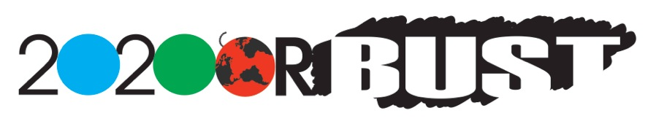
Global Launch of “2020 or Bust”
The citizen engagement campaign to end the climate crisis

When: Thursday, 17 November from 16:30 to 17:00 hours (4:30 pm – 5:00 pm). Where: Press Conference Room Dakhla in the Blue Zone of the conference centre Contact: Laughlin Artz, Executive Director, 2020 or Bust
lartz@2020orbust.org

The mission of “2020 or Bust” is to mobilize the world to end the climate crisis, and to rally humanity around the next four years as our make-it-or-break-it window of opportunity in making that happen.
Ending the climate crisis - not mitigating, adapting, debating or studying it requires a whole new way of thinking and acting. For the past three years, a team of dedicated scientists, civil society activists, partners from UNDP, UNEP (including authors of the Emissions Gap Report), UNICEF, along with NGO partners such as CCEN and Give Me 5 have developed the science, models and action scenarios that make ending the climate crisis not only achievable but achievable through the actions of individuals. Thus was born 2020 or Bust.
Where the sum of national policy action fails to rise to meet the climate challenge, as with the Paris Agreement, 2020 or Bust empowers people to bridge that gap between policy and results, which in real time means bridging the critical 2020 annual emissions gap of 8 Gt.
Also being launched is our phone app, making participation easy, pop-culture, actionable and fun. The app lets people play “2020 or Bust: The Game of the Century.” Picking from a menu of actions to take, people get into action to bridge their individual gap, which is then aggregated into the global game. We are making ending the climate crisis go viral.
COP22 marks the official global launch of 2020 or Bust.
We invite, request, and urge your participation in this historic endeavor – the world’s largest citizen engagement campaign ever.
www.2020orbust.org

